Hydrometallurgy: Proposed Modifications
Original workflow, suggested changes and minimized workflow
Assignment component 2. The modifications below are process-integration suggestions intended to reduce unnecessary handling and improve efficiency while preserving the same overall recovery sequence.

1. Original workflow
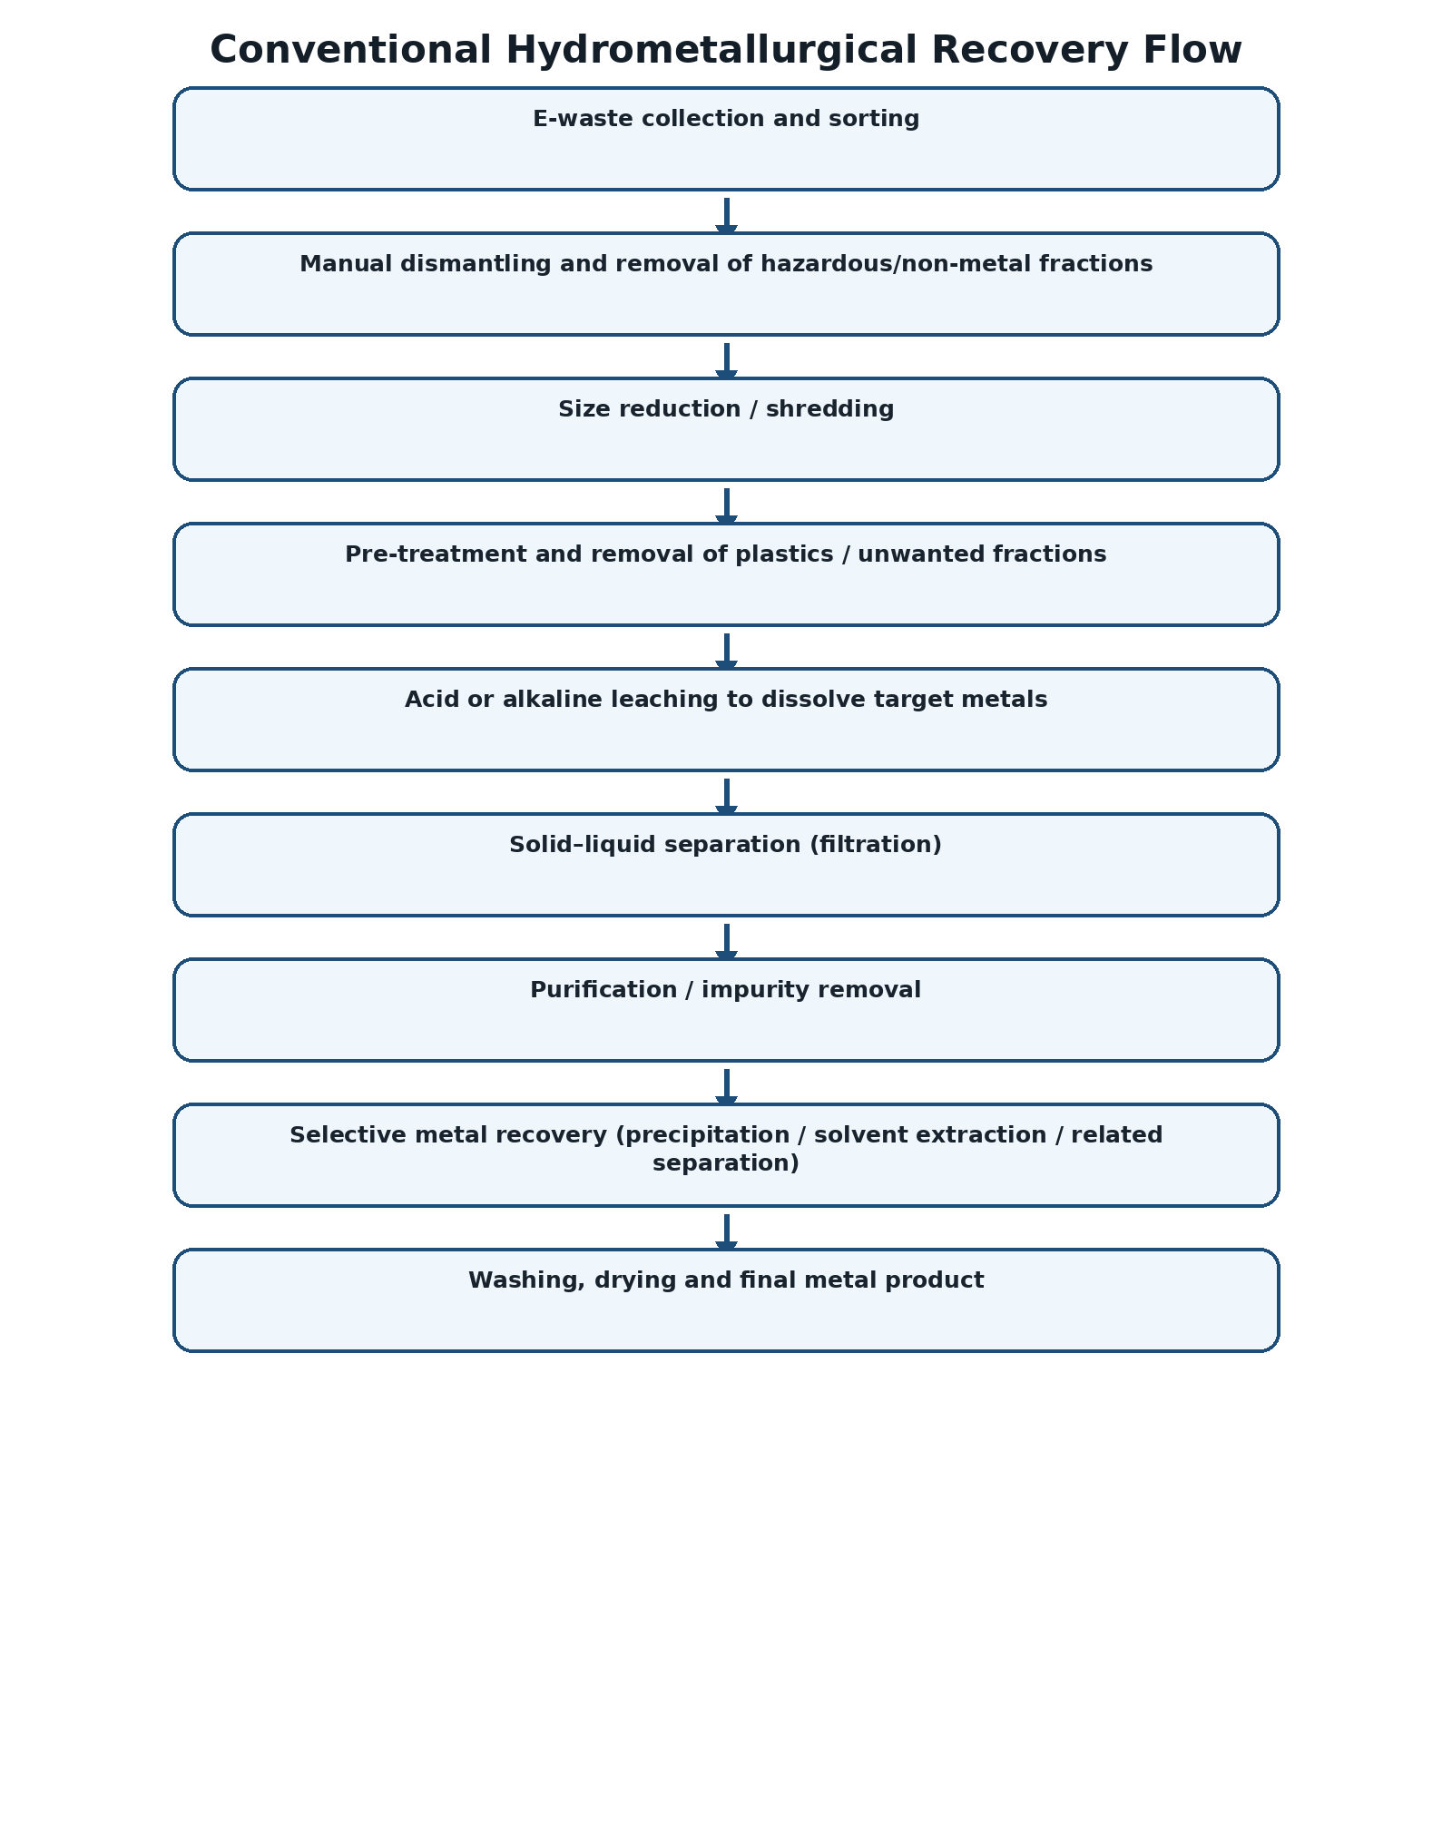

2. Suggested minimized workflow
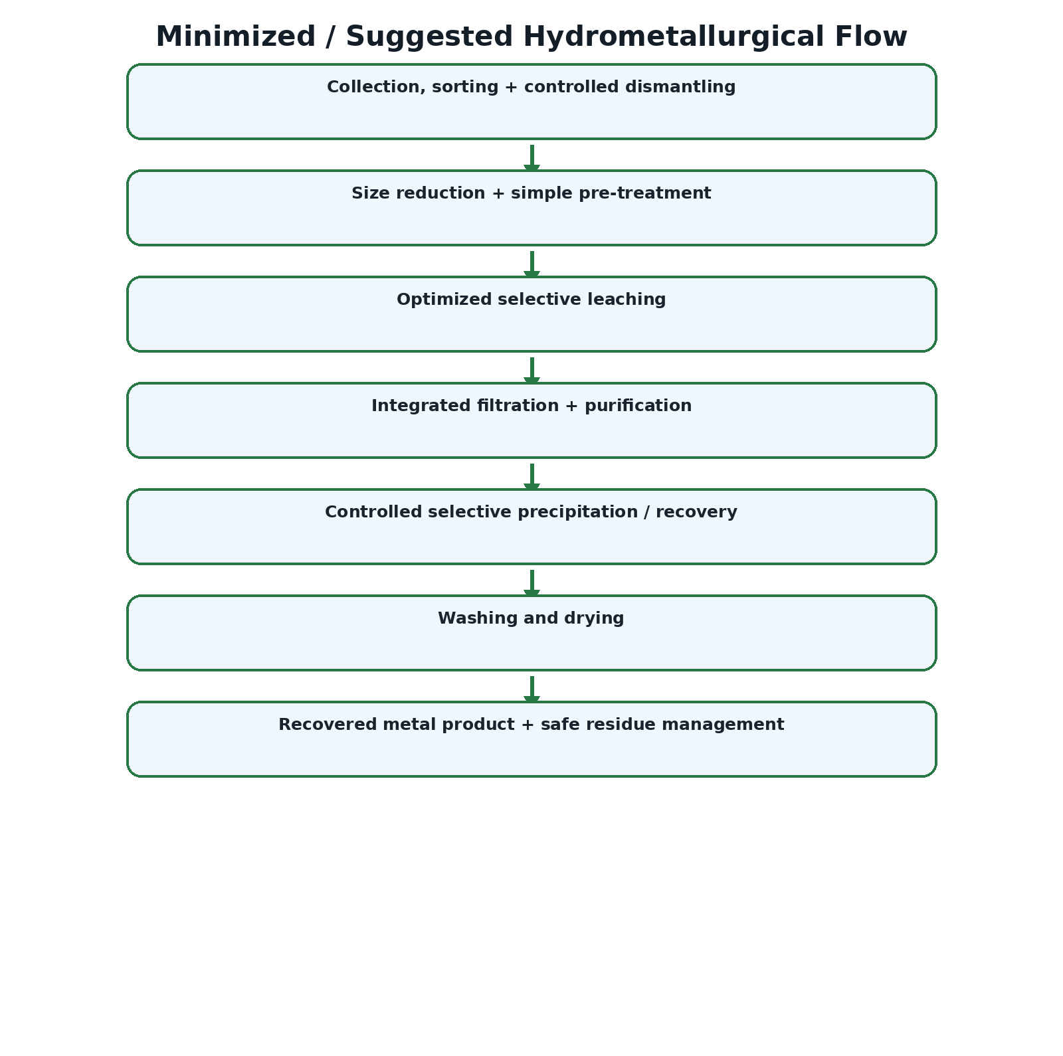

3. What has been changed?
Original | Suggested change | Reason | Expected benefit
Separate collection + sorting + dismantling | Combine into one controlled preparation stage | These operations are sequential preparation steps | Less handling and simpler workflow
Separate size reduction and basic pre-treatment | Integrate size control with pre-treatment | Both prepare the feed for leaching | Lower handling time
Separate filtration and early purification | Use integrated solid–liquid separation followed by purification | Reduces unnecessary transfers between vessels | Lower transfer losses and time
Multiple recovery operations | Use controlled selective precipitation/recovery where chemistry permits | Consolidates the final recovery stage | Simpler downstream operation
Repeated washing/drying | Single controlled final washing and drying | Avoids repeated handling of recovered product | Lower water/energy use

4. Modified process – detailed steps
- Collection, sorting and controlled dismantling are treated as one feed-preparation stage.
- Size reduction is combined with simple pre-treatment so the leaching feed has a more consistent particle size and lower unwanted fraction.
- Leaching is optimized for the selected target metal(s), avoiding unnecessarily severe conditions.
- Filtration is integrated with the purification sequence to minimize solution transfers.
- Selective precipitation or another suitable recovery operation is controlled to recover the target metal from the purified solution.
- The recovered product is washed and dried once under controlled conditions.
- Solid and liquid residues are collected for safe treatment, reuse or disposal as applicable.

5. Visual summary of changes
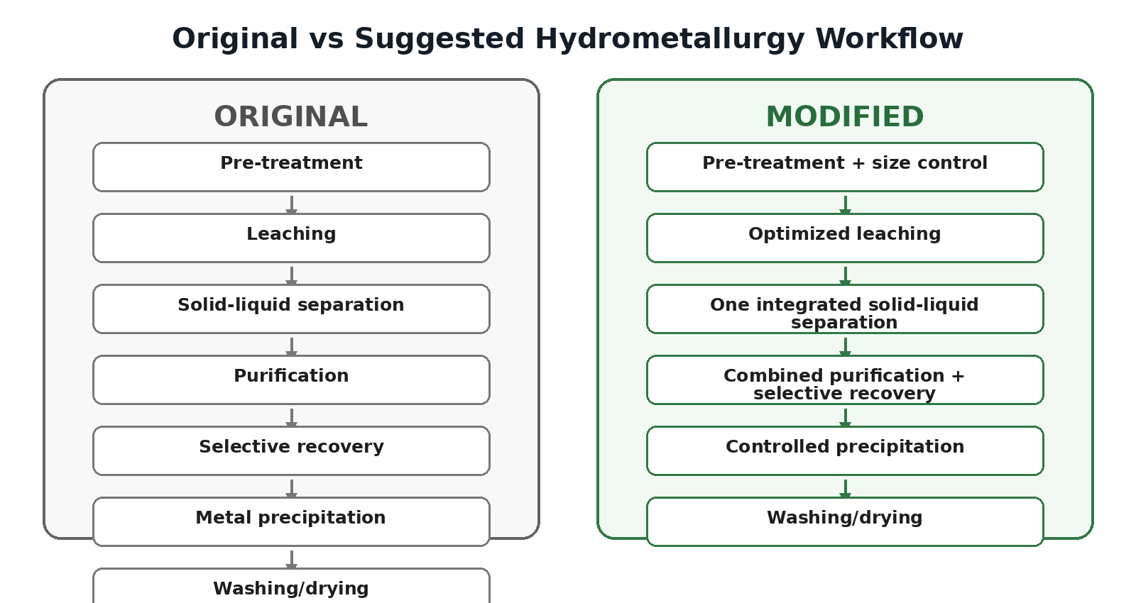

6. Important qualification
The proposed changes are process-design suggestions, not experimentally validated operating conditions. Reagent concentration, temperature, pH, residence time and recovery yield must be optimized experimentally for a specific e-waste feed before industrial implementation.

7. Expected overall improvement
- Fewer major handling stages.
- Reduced solution transfers and associated losses.
- Simpler process monitoring.
- Potential reduction in processing time and water/energy use.
- Same core hydrometallurgical principle: dissolve → separate → purify → recover.

